Instruction Sheet for Webinar Participants
Webinar: Continuous Improvement – A Way of Being
January 25, 2017

Thank you for joining our upcoming webinar. In preparation and to maximize the benefit from participating in the webinar, we ask that you read and complete the provided Continuous Improvement Self-Assessment Tool.
The below instructions will take you step-by-step through how to complete the Continuous Self-Assessment Tool by using the Self-Assessment Tool Criteria Grid.
This will take about 15 – 20 minutes of your time.
The Continuous Improvement Self-Assessment Tool is intended to be completed by a team; an opportunity to review and reflect on how organizations and services are doing, specific to each of the attributes of continuous improvement. For the purposes of our session, please complete the Self-Assessment Tool on your own.
Go through each question and based on the criterial provided for each response, plot your answer on the grid. Please complete your grid prior to the session and have it with you during the session for discussion. There is no “right” or “wrong” answers, simply an opportunity to engage and learn from your responses. After the webinar, we encourage you to use this tool as a resource during your continuous improvement journey for your teams and services.
Continuous Improvement Self-Assessment Tool
The Continuous Improvement Self-Assessment Tool identifies 8 unique attributes of Continuous Improvement and provides space to indicate a rating (0 - 4) for each attribute.
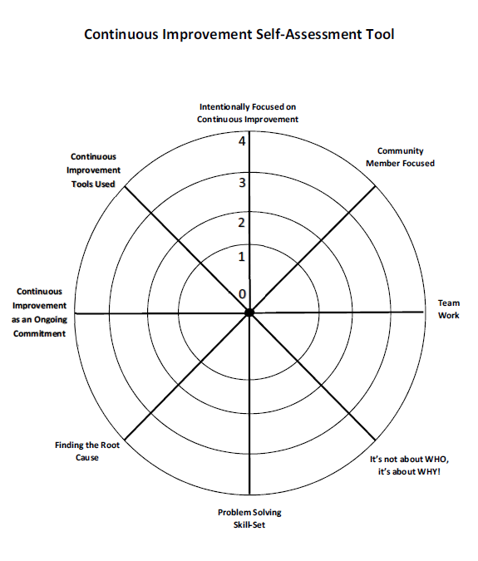
The attributes are:
- Intentionally focused on continuous improvement
- Community member focused
- Team work
- It’s not about WHO, it’s about WHY!
- Fostering an environment that uses problem
solving skills
- Finding the root cause
- Continuous improvement as an ongoing
commitment
- Continuous improvement tools used
Continuous Improvement Self-Assessment Tool Criteria Guide
In order to help organizations to rate themselves on the 0 – 4 scale, the Continuous Improvement Self-Assessment Tool Criteria Grid has been developed. For each attribute of Continuous Improvement, it provides sample descriptions of organizations for each rating.
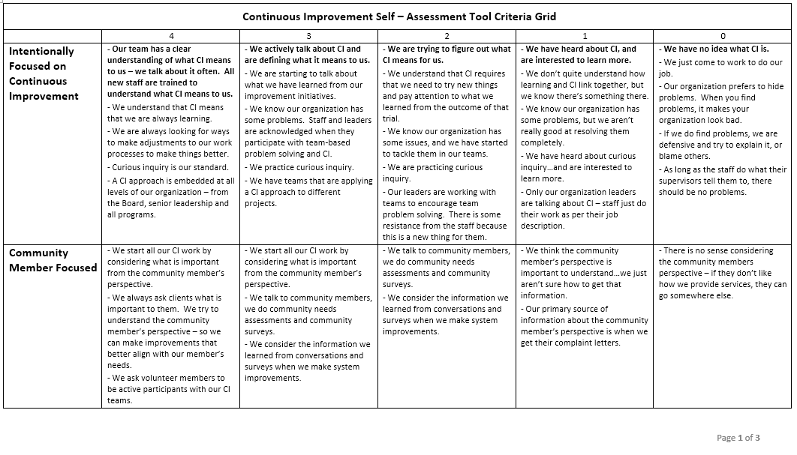

For each attribute, read through each of the rating descriptions starting at 0 and finishing at 4.
The rating which best describes your organization will be the number that you will reflect on the Self-Assessment Tool. Place a dot on the Self-Assessment Tool to indicate the rating.
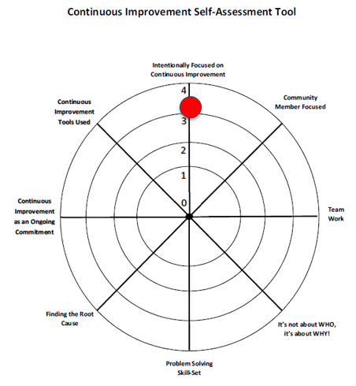
You may find your organization is in between ratings.
In this example, the organization rates itself as 3+. They can identify with all the descriptors in rating 3, PLUS some in rating 4.
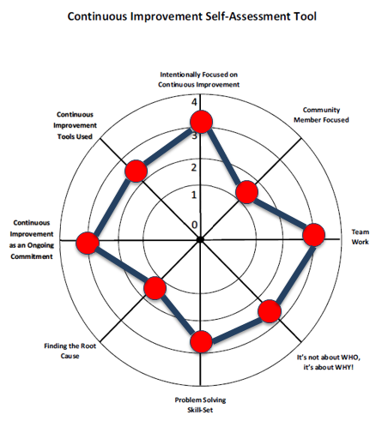

When all of the attributes have been reviewed and rated, connect the dots to create an overall picture of how your organization is doing – and being – at this moment in time along your continuous improvement journey.

